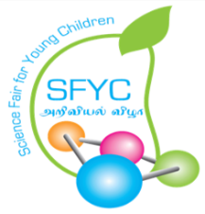
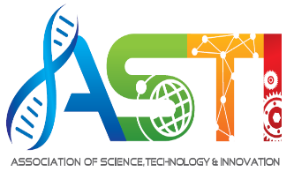
Pertubuhan Sains,Teknologi dan Inovasi (PPM-012-10-25102012)
No.16A, Jalan 21/12, Sea Park, 46300 Petaling Jaya, Selangor
Tel: 03-78778571/03-78655557
Email:nsfyc00@gmail.com
Association of Science Technology and Innovation (ASTI) is an association for the promotion of education and understanding in scientific knowledge and also the organizer of Science Fair for Young Children (SFYC). ASTI would like to honor teachers who have contributed to the student’s achievements in SFYC as well as other National and international science and innovation-based competitions; as well as other related achievement such as students’ scores improvement, teaching during Covid-19 Lockdown, etc. Therefore, teachers are invited to complete this form and submit to ASTI by 10th August 2024. An Independent panel of jury will select the award winners.

School:

Name:

Contact:

Email Address:

1. List of involvement in Science Fair for Young Children:

2. List of achievement in Science Fair for Young Children and other National and International science/innovation competitions.

3. List your other contribution in helping your students achieve and excel in the areas of STEM (Science Technology Engineering and Mathematics)

4. Please write in 3-5 sentences your motivation to be involved in the advancement of your student:

5. School Head Master’s endorsement.

Note:
Please submit your application form together with scanned copy of certificates where applicable.
You may use another sheet of paper as an appendix if required.

Science, Technology and Innovation in Action

